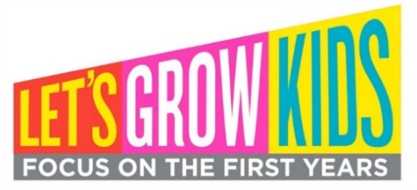
MEDIA ADVISORY
MEDIA CONTACT: [Volunteer Name, phone number, email]
Kids anthem flash mob to bring [xx#] Vermonters to [location] to raise awareness for high-quality, affordable child care
WHAT: Early childhood advocates will convene in [town] at [event name, if relevant] for a flash mob performance of the “Something Beautiful” anthem for kids as part of a growing statewide movement for affordable access to high-quality child care. “Something Beautiful” was co-written by Vermont musicians Kat Wright and Chris Dorman (aka Mister Chris) with accompanying dance movements by choreographer Lois Trombley. This flash mob is one of many happening in communities across the state this summer and fall led by advocates who are organizing in support of increased public investments in Vermont’s child care system. The anthem was first performed at an event hosted by Let’s Grow Kids in 2017 that included a 1,000-person flash mob and live concert on Burlington’s Church Street Marketplace. To watch the “Something Beautiful” music video and learn the flash mob dance moves, visit Let’s Grow Kids’ website at www.letsgrowkids.org/kids-anthem
WHEN: [Day of week, date, time of day]
WHERE: [Specific location with address]
WHY: Equitable access to high-quality child care would level the playing field for Vermont children, ensuring a stronger, healthier future for Vermont. Right now, more than half of Vermont infants and toddlers who are likely to need child care don't have access to any regulated care, and nearly 80% don't have access to high-quality programs. Let’s Grow Kids, a statewide campaign working to ensure that every family has affordable access to high-quality child care, is empowering advocates in every corner of the state to mobilize the movement. Learn more at www.letsgrowkids.org.

# # #

